**DATE: 18.10.2019**

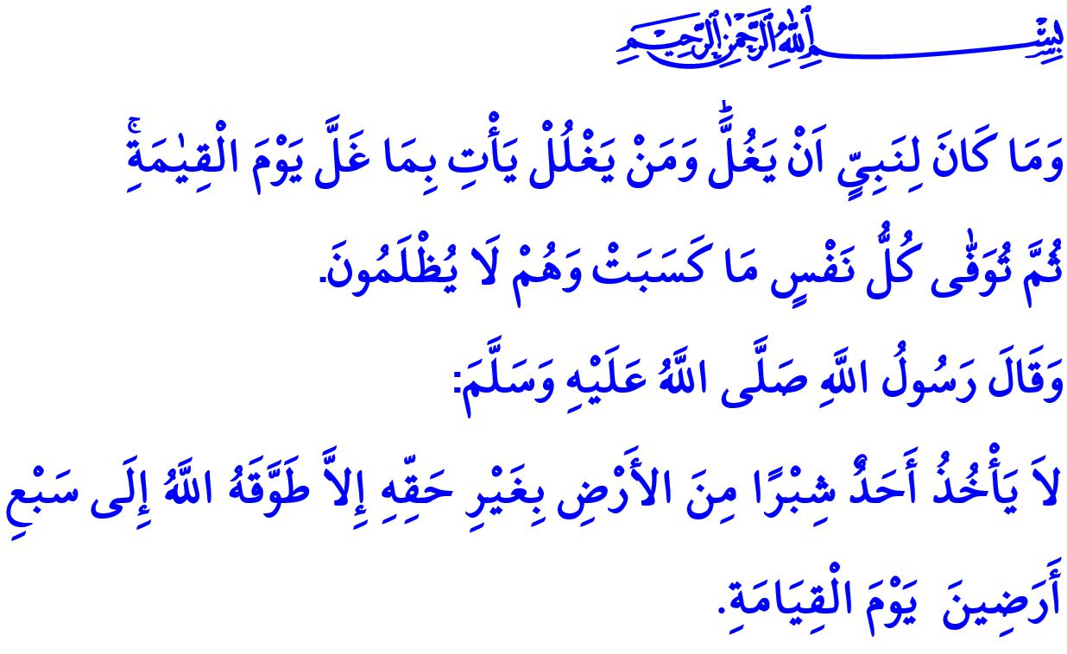

**INDIVIDUAL AND PUBLIC RIGHTS**

**Honorable Muslims!**

One day the Prophet Muhammad (saw) asked his companions**, “Do you know who is a muflis (bankrupt)?”** His companions there replied, “O Rasulullah, a muflis is one who has neither money nor any property.”

Thereupon, he said, “**The real bankrupt would be those who would come on the Day of Resurrection with salat, sawm, and sadaqah, but they will find themselves bankrupt on that day as they will have exhausted the good deed because they reviled others, brought calumny against others, unlawfully devoured the wealth of others, shed the blood of others, and beat others; therefore, their good deeds would be credited to the account of those who suffered at their hands. If their good deeds fall short to clear the account, their sins would be entered in their accounts and they would be thrown in the Hellfire.”[1]**

**Dear Muslims!**

Islam is the religion of rightfulness, truth, law, and justice. The concept of "right" denotes both our responsibilities and the values that we need to protect. Our source of life and peace, the revelations by Allah (swt) invite us to protecting the right. One of the Asma al-Husna (the Beautiful Names of Allah) is **"al- Haqq"**. For this reason, when people are in pursuit of the right, they actually take the side of the righteousness and the truth, that is the conformity to Allah's (swt) commandments and consent.

**Dear Believers!**

Humans, from the moment they fall into the mother's womb, have the right to life and the security of life. This principle is referred to in the words of Allah the Almighty (swt) as follows, “**Whoever kills a soul unless for a soul or for corruption done in the land, it is as if he had slain mankind entirely. And whoever saves one, it is as if he had saved mankind entirely.”[2]**

Every person has the right to protecting their property and legitimate income. Engaged in haram are those people who gain property illicitly, deceive theircustomers by resorting to fraud in business, and do not pay, thereby stealing from, their employee's rightful share.

Inviolable are people's individual values, honor, chastity, and beliefs. Among the worst violations of rights are considered to insult people's values, defame them, and damage their reputation by uttering lies and slanders about them. The violation of rights is a crime according to our laws in force, and a grave sin according to Islam.

**Honorable Muslims!**

Being a Muslim requires all of us to adopt a middle-of-the-path approach, be conscientious, and righteous in all domains of life. A distinctive sign of being a Muslim is to protect their own rights and the rights of other people around them. People who encroach upon the rights of other people, as well as of animals and the nature, for personal interests and benefits are doomed to lose and go brankrupt in the end although they may seem to gain profit in the first place.

Being a responsible person conscious of the rights requires giving the rightful due to whoever has the right, particularly the family members in the closest circle. Respecting the rights of our parents, observing the rights of our spouses duly and lovingly, and protecting the rights of our children compassionately are all responsibilities upon us. It is a duty upon all of us to strive to ensure that the rightful due is paid for those involved in kinship relations, particularly those who are party to any business partnership, wedding, or inheritance.

**Dear Believers!**

The sphere completely influenced by the rights of individuals is that of the rights of the public. The rights of the public require us to be even more responsible compared to the rights of individuals. Failure to observe the rights of the public drag people to frustration both in this world and in the Hereafter. In this regard states the Almighty Allah (swt), “**No prophet could (ever) be false to his trust. If any person is so false, they shall, on the Day of Judgment, restore what they misappropriated, and then shall every soul receive its due, whatever it earned, and none shall be dealt with unjustly.”[3]** Similarly, the Prophet Muhammad (saw) warned his ummah, **"Whoever takes a piece of the land of others unjustly, he will sink down the seven earths on the Day of Resurrection."**On another occasion, he said, [4] **Whoever is charged with a work and earns wage in turn, everything that he gets except for this earning is the breach of trust. [5]**

**Dear Muslims!**

Let us not forget that the relations based on righteousness lead to peace in this world and salvation in the Hereafter. Let us be careful not to infringe the rights of other people in our private life. Let us perform our public duties and services as conscious of them being entrusted to us for a given period of time, Keeping in mind that we are responsible even for the rights of orphans This is so because any right of the public infringed and any public property damaged mean thousands of rights of individuals violated. Let us live in the know of the fact that just as every good deed has its rewards, every negligence and mistake will cause the violation of the rights of individuals and of the public.

1. Muslim, Birr, 59.
2. Ma'idah, 5/32.
3. Al-i 'Imran, 3/161.
4. Muslim, Musakat, 141.
5. Abu Dawud, Haraj, Fay' wa Imara, 9-10.

   **General Directorate of Religious Services**